Supplementary Information S3 : Sensitivity analysis

Executive Summary
This study investigates the spatial behavior of soil fauna in relation to root systems, challenging the notion of the rhizosphere as a simple, static attraction zone. By integrating null model simulations with Generalized Additive Models (GAMs), we decouple biological selection from physical habitat constraints and reveal that the demographic benefits of rhizosphere exploitation are governed by a distinct temporal lag.

0. Raw data exploration
Table 1: Summary of invertebrates occurrences and sampling effort
 | Biological Data | Sampling Effort
Taxon | Total occurrences | Sample images | Mean occurrence per image
acari | 429 | 264 | 1.62
collembola | 1,991 | 444 | 4.48
gastropoda | 994 | 316 | 3.15
Total unique images analyzed: 541
Total scanner units: 8
Total period units: 7
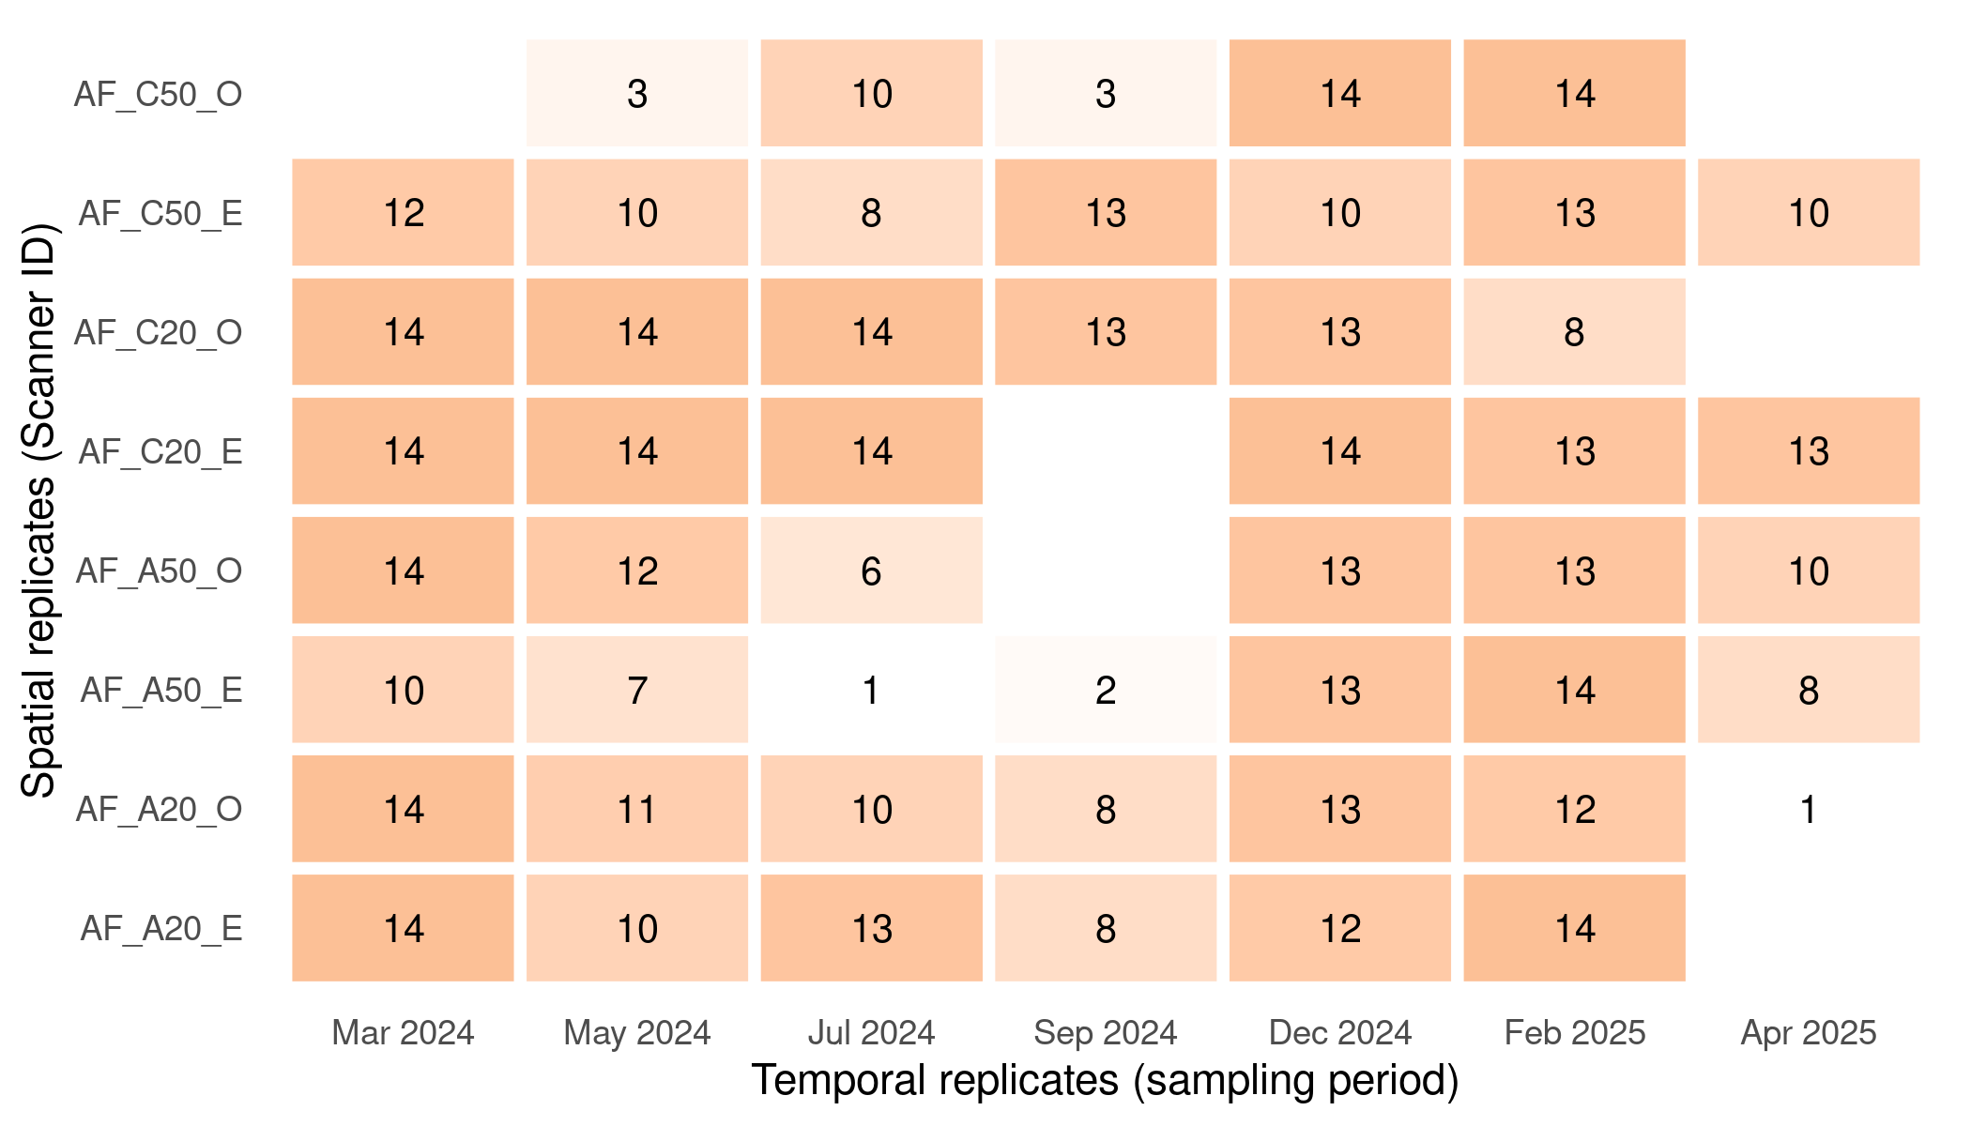
Figure 1: Spatio-temporal sampling effort : total images analyzed per scanner and period
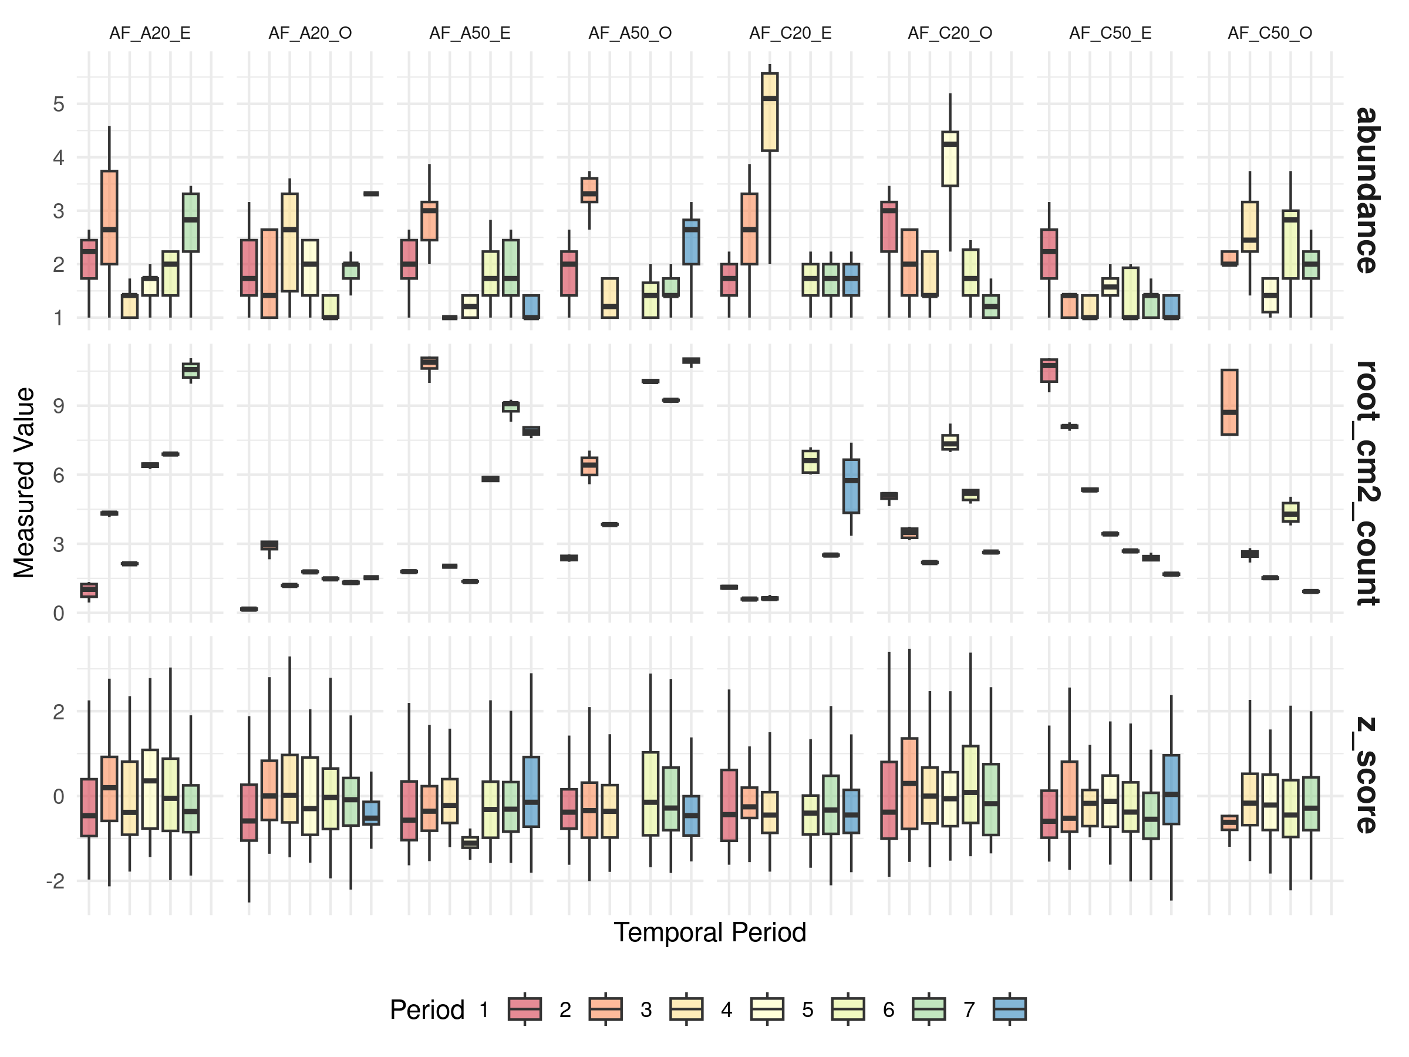
(a) Rows: Biological and Environmental metrics | Columns: Spatial replicates (Scanners)
Figure 2: Replicate-level variability of studied metrics

1. The rhizosphere effect: attraction and spatial signature
To quantify habitat selection, we adapted techniques widely used in radio-tracking studies (Calenge et al. 2005) based on the notion of marginality (the deviation between available habitat conditions and those used by animals). We overlaid invertebrate occurrence data onto high-resolution root distance maps, calculating the distance from each individual’s centroid detection to the nearest root. To characterize habitat availability, we projected 50 random points onto the corresponding root distance map for every invertebrate occurrence. We then derived the Standardized Effect Size (SES) for marginality index (a.k.a., Z-score) by calculating the deviation of the observed distance from the mean null expected distance, scaled by the expected standard deviation. This index serves as a measure of spatial marginality, where negative values indicate organisms are closer to roots than expected by chance and positive values indicate they are farther than expected relative to a random distribution. Hereafter, we use the terms ‘selection’ and ‘avoidance’ in a strictly statistical sense to denote consistent negative or positive spatial deviations from the null expectation, respectively; these terms describe observed spatial patterns and do not imply intentional or fitness-driven behavioral choices.

Why use Z-scores instead of simple differences?
To evaluate whether soil fauna actively select the rhizosphere, we must distinguish between biological attraction and spatial chance. We utilized a standardized selection index ($z$-score) calculated as:
$$z=\frac{Observed−Expected}{SD_{expected}}$$
A simple arithmetic difference ($Observed−Expected$) is statistically flawed for comparing different habitats due to scaling bias. The “randomness” of an animal’s position is dictated by the underlying geometry complexity of the habitat, captured by the integrated spatial sd ($SD_{expected}$). If we rely on unnormalized differences, we encounter two major issues:
- Scale sensitivity: A 1cm deviation is a massive biological signal in a dense, low-sd root system, but merely “statistical noise” in a sparse, high-sd environment.
- Heteroscedasticity: As shown in the following “unnormalized signal” plot, the variance of the raw difference expands as spatial uncertainty increases. This fan shape indicates that the metric’s reliability is inconsistent across the dataset.
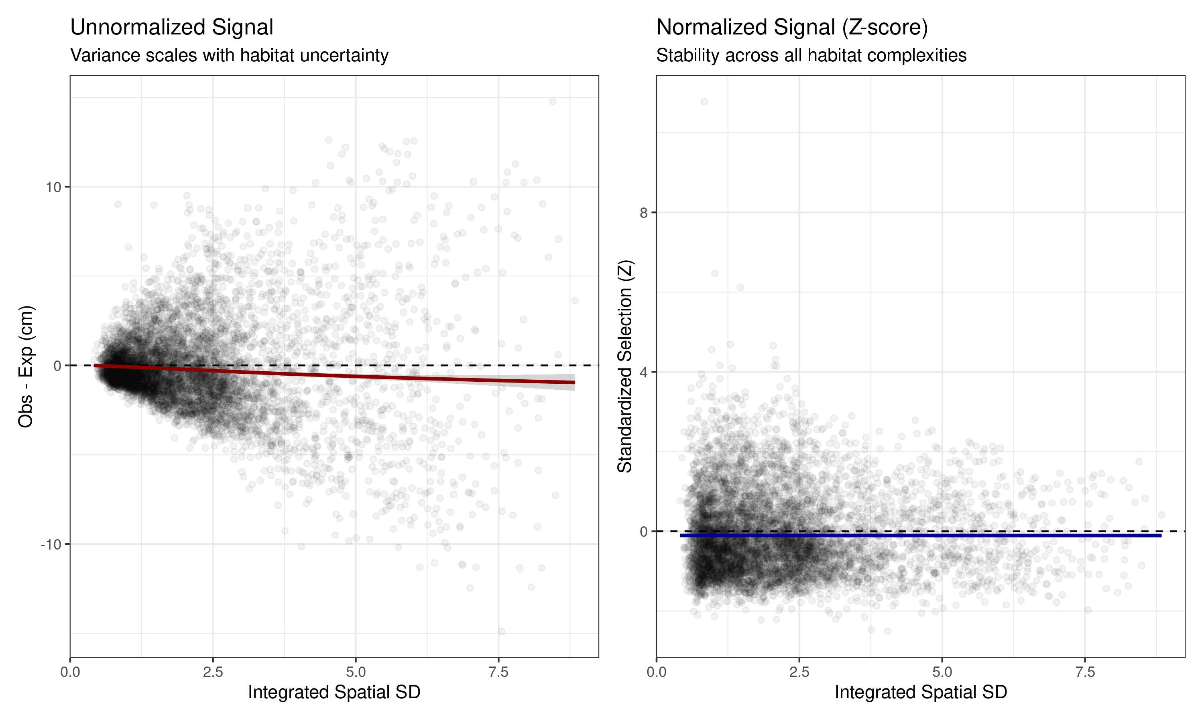
Figure 3: Normalization comparison
The “normalized signal” plot shows that the $z$-score remains more stable across the whole range of spatial complexities. This process tend to filters out stochastic noise and ensuring that a high negative $z$-score consistently indicates a biological “pull” toward the root, regardless of the complexity of the habitat.

Do soil fauna actively select the rhizosphere space ?
The central hypothesis of this study, which concerns the influence of roots on the spatial distribution of soil invertebrates, was first examined by testing for departures from random root-associated habitat use. Normalized marginality values were tested against zero using Wilcoxon signed-rank tests. Given the hypothesized functional specificities of organisms and root traits, these tests were conducted independently for each invertebrate taxon and root functional category.
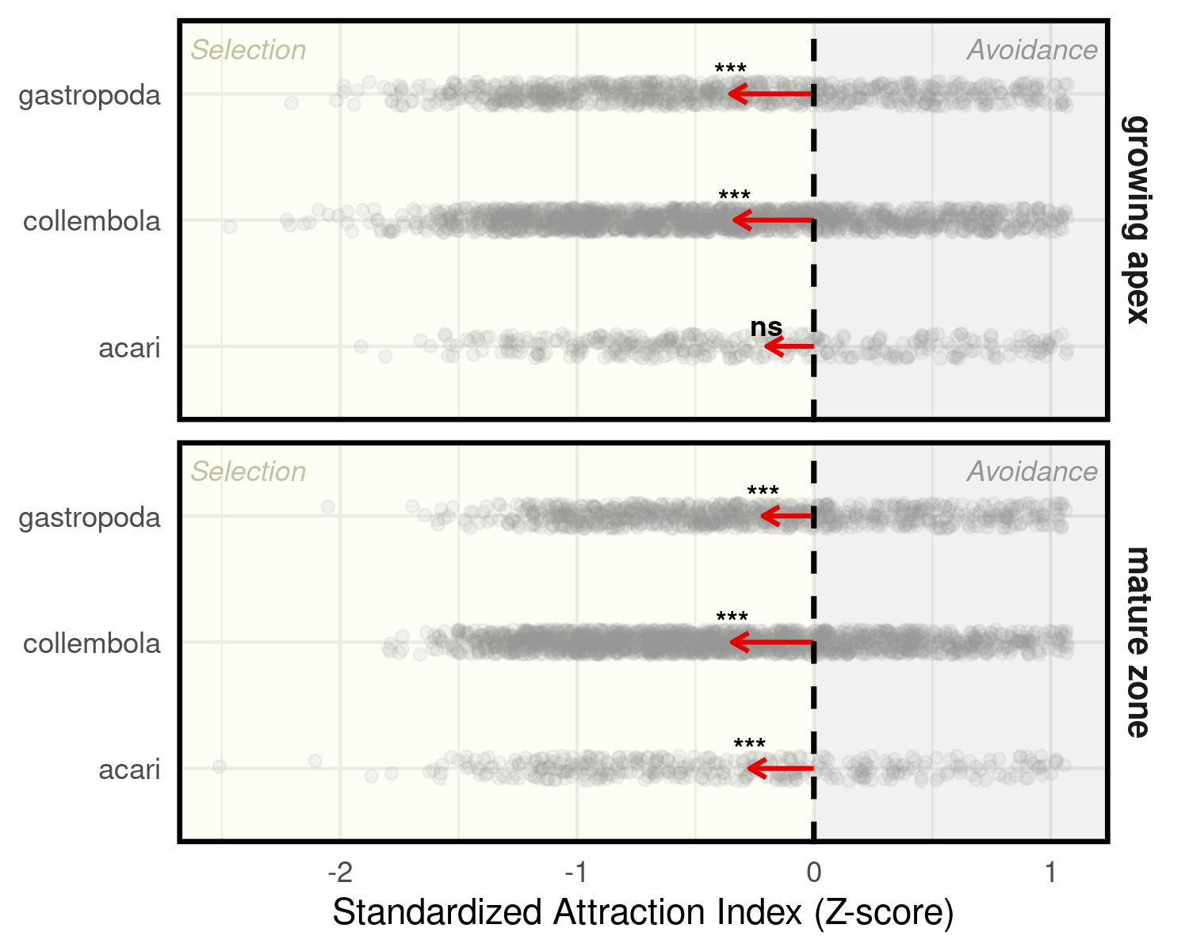
(a) Negative Z-scores indicate active selection of the root zone
Figure 4: Rhizosphere Attraction Index
The Figure 4 reveals significant, taxa-specific attraction to the root surface, particularly for Collembola and Gastropoda. The strength of this selection varies by root type, suggesting that biological drivers - such as root exudation - shape spatial clustering beyond what is expected by chance.

2. The geometric niche: habitat availability constraint

Context
While attraction is a key driver, the physical presence of roots inherently constrains the available habitat. As surface root density increases, bulk soil volume diminishes, mathematically increasing the probability of fauna-root encounters regardless of biological preference. To isolate the true “biological signal,” we wanted to model the $z$-score across a surface root density gradient.

Addressing spatial-temporal autocorrelation
In our experimental setup, surface root density within a specific scanner over a 7-day period is often stable (see Figure 2). This creates a statistical challenge: if we model every individual occurrence, we treat each one as an independent “choice.” However, occurrences within the same scanner and period are constrained by the same physical architecture. To avoid artificially inflating our degrees of freedom and providing a biased estimate of the “geometric niche,” we performed a sensitivity analysis :
- Individual-Level Model: High resolution, but susceptible to Type I errors due to high intra-replicate autocorrelation.
- Aggregated-Level Model: data is collapsed to Scanner × Period × Taxon × Root type means. This ensures that each data point represents a unique “habitat state,” forcing the model to look for trends across experimental units rather than individual points.
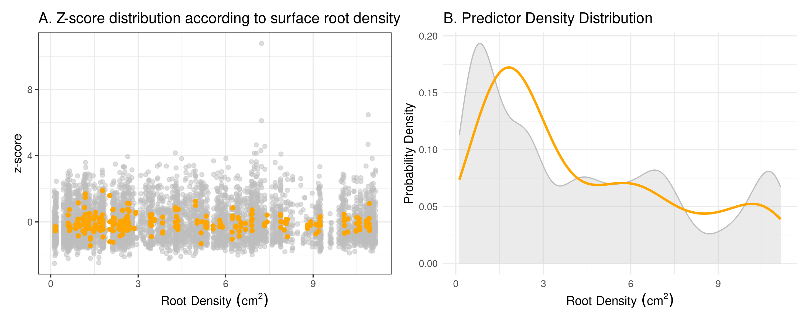
(a) Grey: individual observations | Orange: Replicate averages (aggregated)
Figure 5: Structural impact of data aggregation
The “vertical striping” in Figure 5 (A) highlights the pseudo-replication issue: many fauna share identical surface root density values. The aggregation process in Figure 5 (B) preserves the experimental gradient while smoothing over-represented low-density zones, providing a more balanced predictor distribution.

Distribution choice: Why scat()?
The selection of the scaled $t$-family (scat()) was necessitated by the “heavy-tailed” nature of $z$-scores in this system. Ecological data often contain extreme behaviors—individuals that are exceptionally attracted to or repelled by a resource - that create outliers beyond what a standard Gaussian (Normal) distribution can accommodate. As shown in the comparative QQ-plots, the scat family accounts for these heavy tails, preventing extreme values from disproportionately pulling the fitted splines.
df AIC
mod_gaussian 19.26655 401.1098
mod_aggregated 23.61698 364.4128
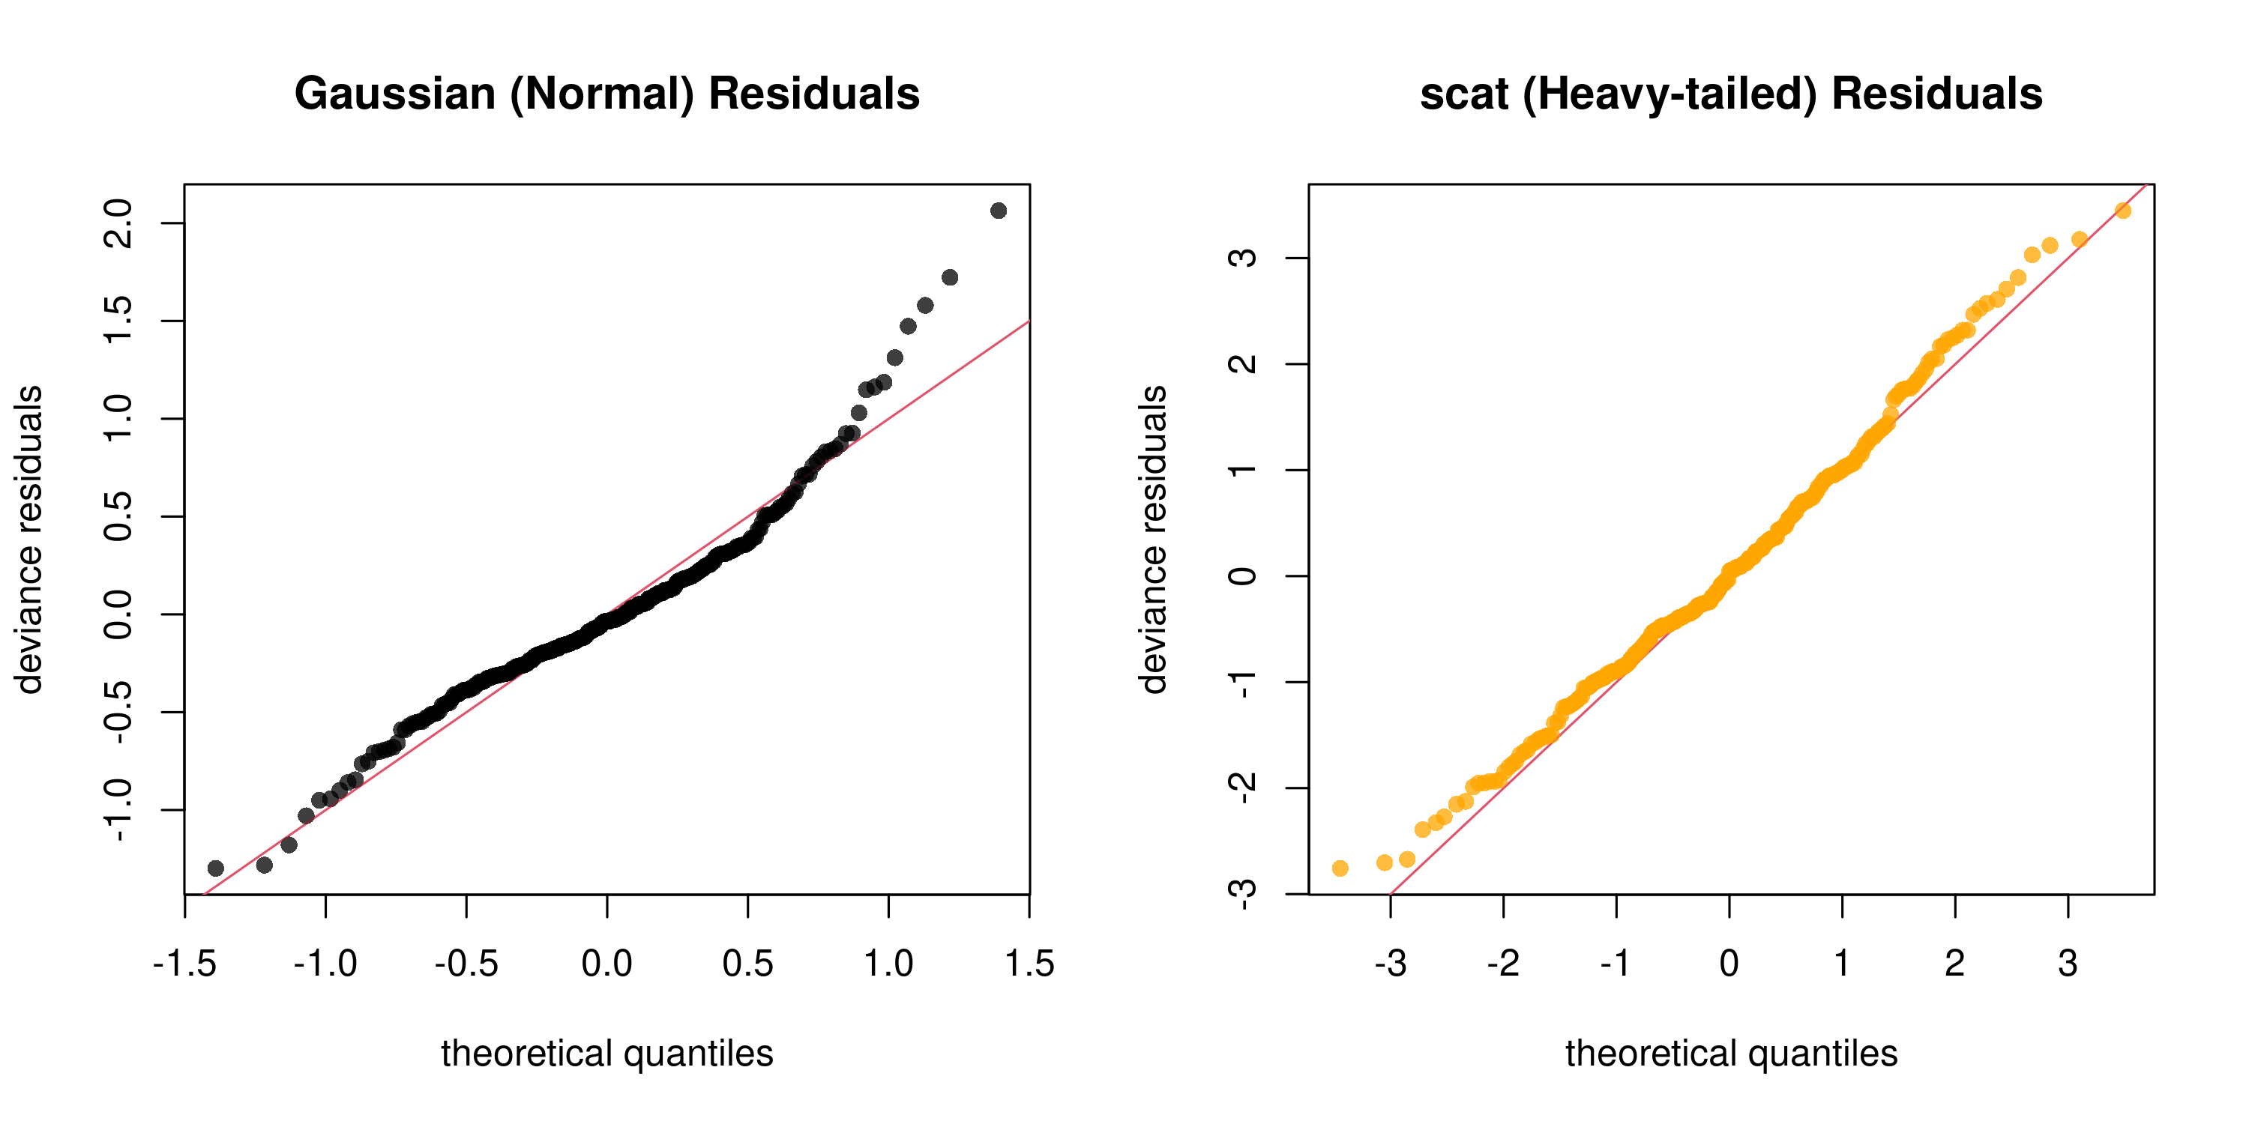
Figure 6

Results models comparison
We implemented two Generalized Additive Models (GAMs) using the scat() family (scaled $t$-distribution) : individual vs aggregated model.
Table 2: Sensitivity analysis - comparison of individual vs. aggregated modeling approaches
Model Approach | AIC | Dev. Expl. (%) | Adj. R² | Mean EDF | Significant Smooths | N
Individual | 19,193.622 | 2.117 | 0.022 | 2.798 | 4 / 8 | 6,828
Aggregated | 364.413 | 8.451 | 0.011 | 1.790 | 2 / 8 | 278
The individual model identifies 6 out of 8 smooth terms as significant. However, this significance is deceptive; with a deviance explained of only 2.6%, the model has almost no predictive power. The low p-values are likely a mathematical byproduct of the large sample size and high spatial autocorrelation (pseudo replication). The aggregated model, by collapsing the data to replicate means, eliminate individual-level stochasticity. While the “significance” vanishes (0/8 terms), the deviance explained increases nearly four-fold (9.4%). Furthermore, the average EDF (Effective Degrees of Freedom) drops from ~3.28 to ~1.66, indicating that the model is no longer trying to “wiggle” through noise, but is instead finding a simpler, more stable (though non-significant) trend.

Are fauna close to the root by choice (attraction) or necessity (habitat saturation) ?
While attraction is a key driver, the physical presence of roots inherently constrains the available habitat. As surface root density increases, bulk soil volume diminishes, mathematically increasing the probability of fauna-root encounters regardless of biological preference. To isolate the true “biological signal,” we modeled the $z$-score across a surface root density gradient. We utilized a Generalized Additive Model (GAM) with a Student-t (scat) distribution to account for the heavy-tailed nature of ecological distance data.
Table 3: Summary of smooth term results for surface root density (root_cm2_count) on z_score by root type and taxon
Taxa | Root Type | Complexity (EDF) | Ref.df | Chi-square | p-value | Sign.
acari | growing apex | 1.000 | 1.000 | 1.418 | 0.234 | ns
 | mature zone | 1.000 | 1.000 | 0.550 | 0.458 | ns
collembola | growing apex | 1.429 | 1.718 | 1.472 | 0.533 | ns
 | mature zone | 1.000 | 1.000 | 0.068 | 0.795 | ns
gastropoda | growing apex | 1.000 | 1.000 | 0.454 | 0.500 | ns
 | mature zone | 1.000 | 1.000 | 0.650 | 0.420 | ns
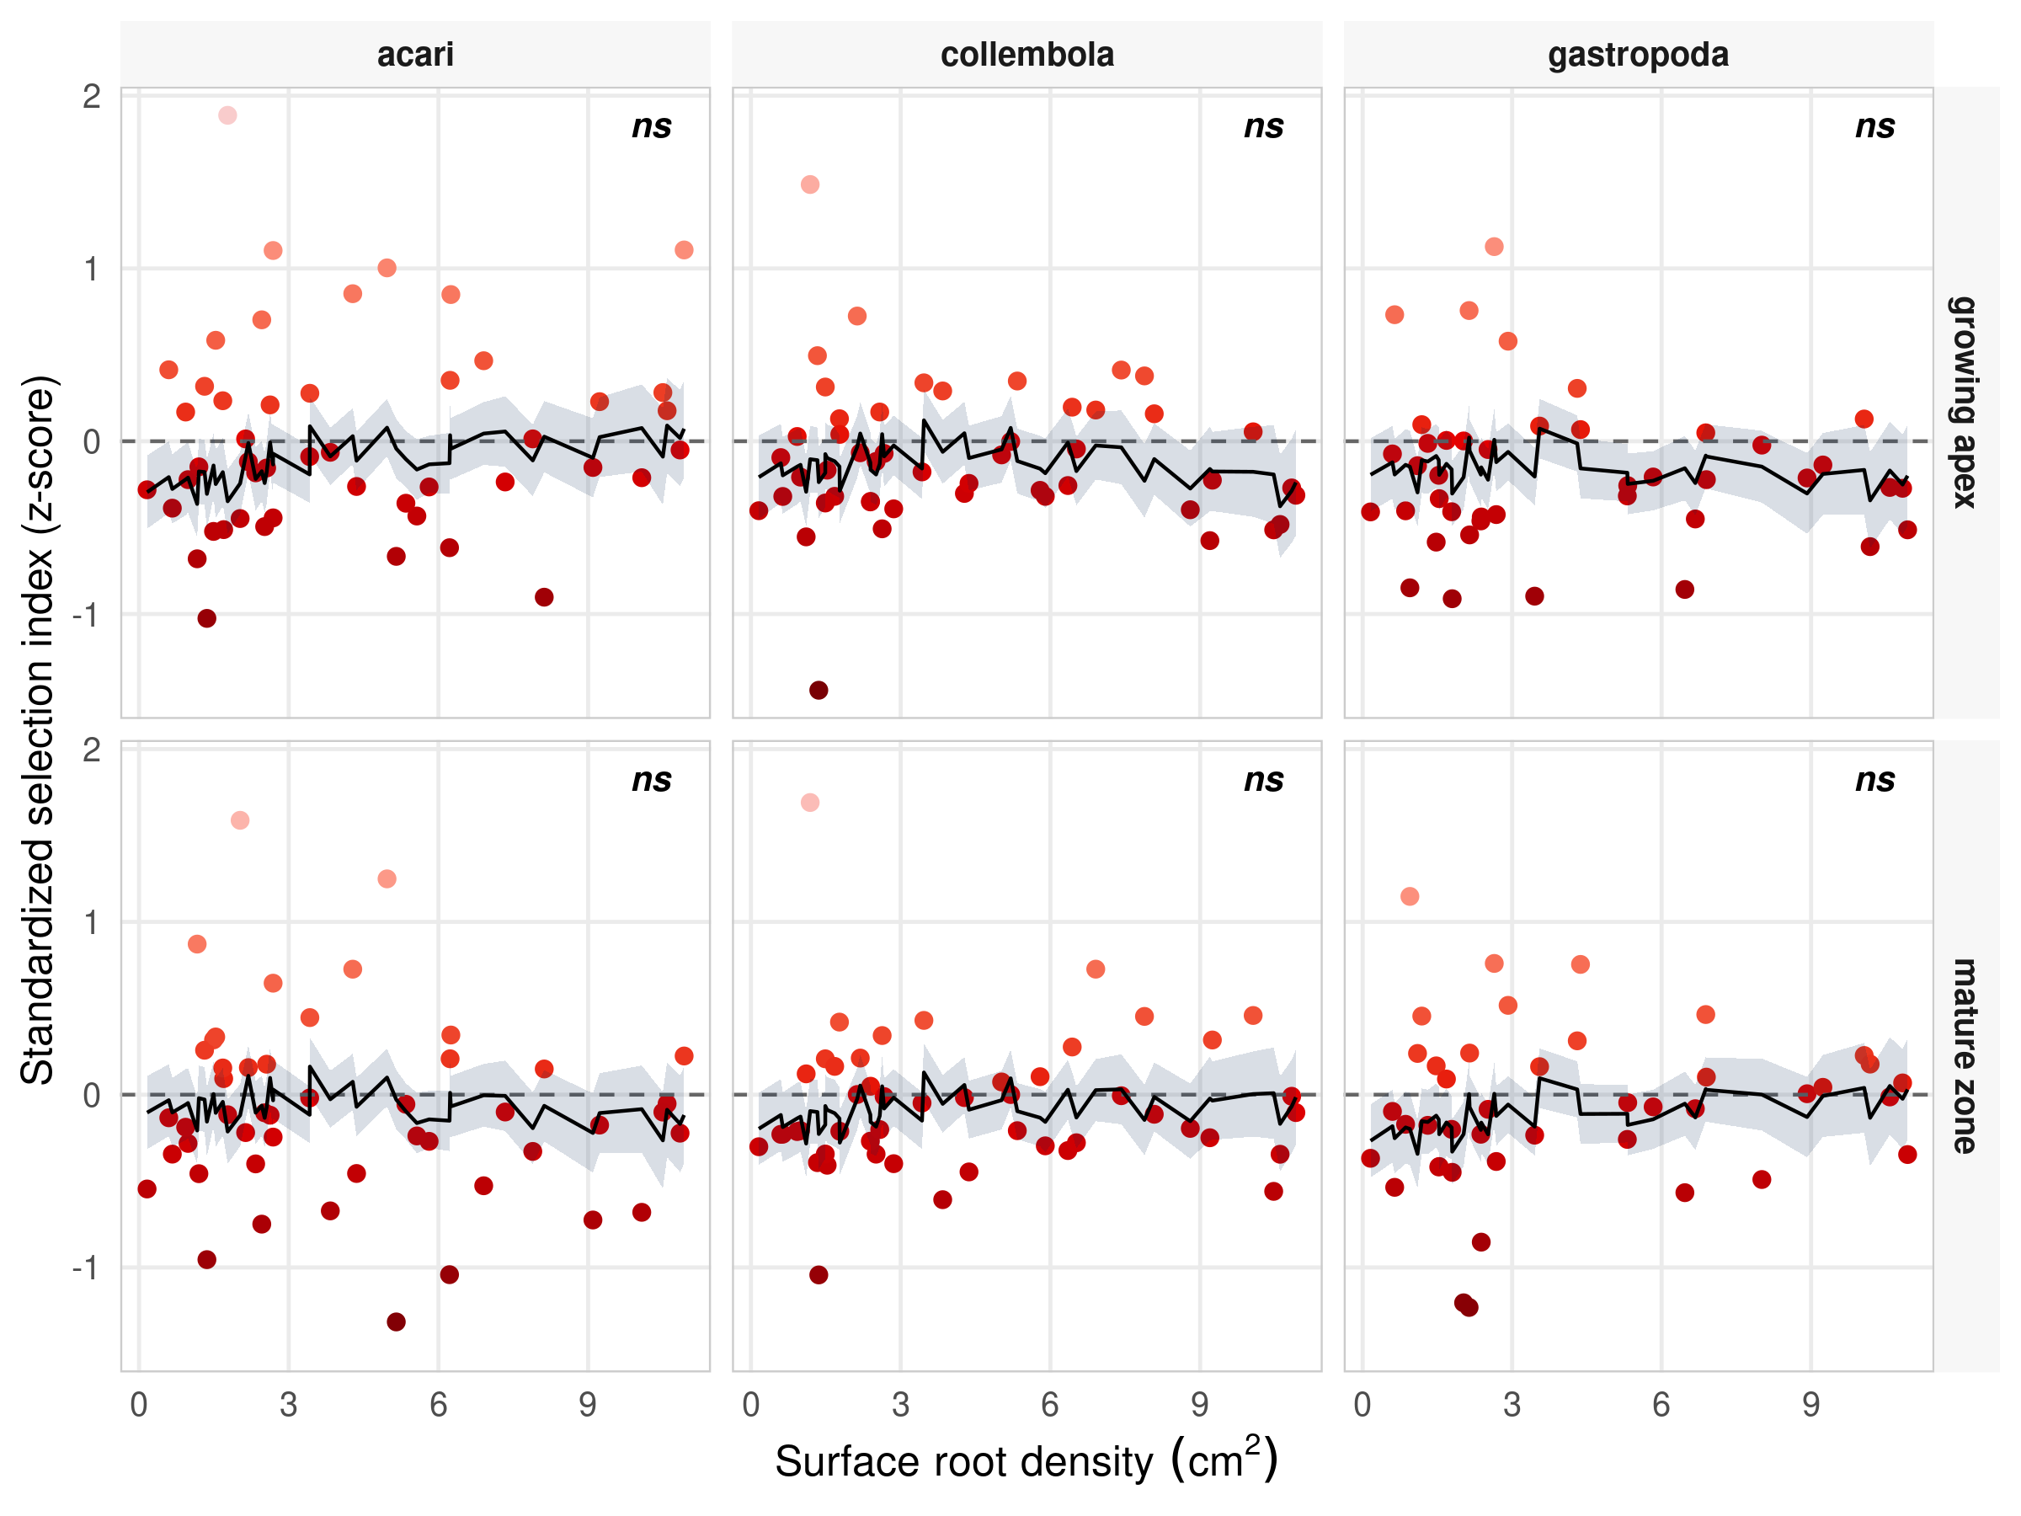
(a) Negative values represent active biological attraction beyond spatial probability
Figure 7: Biological selection vs. geometric constraint
Conclusion: The aggregated model provides a more conservative and honest estimate of the “geometric niche.” It demonstrates that, once individual-level noise is removed, there is no evidence for a strong non-linear selection effect across the surface root density gradient. Root selection is not merely a byproduct of encountering more roots in dense areas, but a consistent biological signal.

3. The selection - demography link : trait or by-product ?

Context
We tested two competing hypotheses to explain the relationship between spatial behavior and population dynamics: a density-driven approach, which tests whether demographic processes dictate spatial behavior, and a performance-based approach, which tests whether the ability to locate and exploit roots leads to population growth.
density_driven_model <- gam(delta.resid ~ Predicted.class.levelup + root_type + s(abundance, by =interaction(Predicted.class.levelup, root_type, drop=TRUE), k=10) + s(scanner, bs="re")+ s(period, bs="re"), family = gaussian(link = "identity"), method = "REML", select = TRUE, data = habitat_delta)
performance_based_model <- gam(abundance ~ Predicted.class.levelup + root_type + s(delta.resid, by = interaction(Predicted.class.levelup, root_type, drop = TRUE), k=5) + s(scanner, bs="re")+ s(period, bs="re"), Gamma(link = "log"), method = "REML", select = TRUE, data = habitat_delta)

Models diagnostic
Prior to inference, we performed a multi-step validation to ensure our model structures were appropriate for the data types.
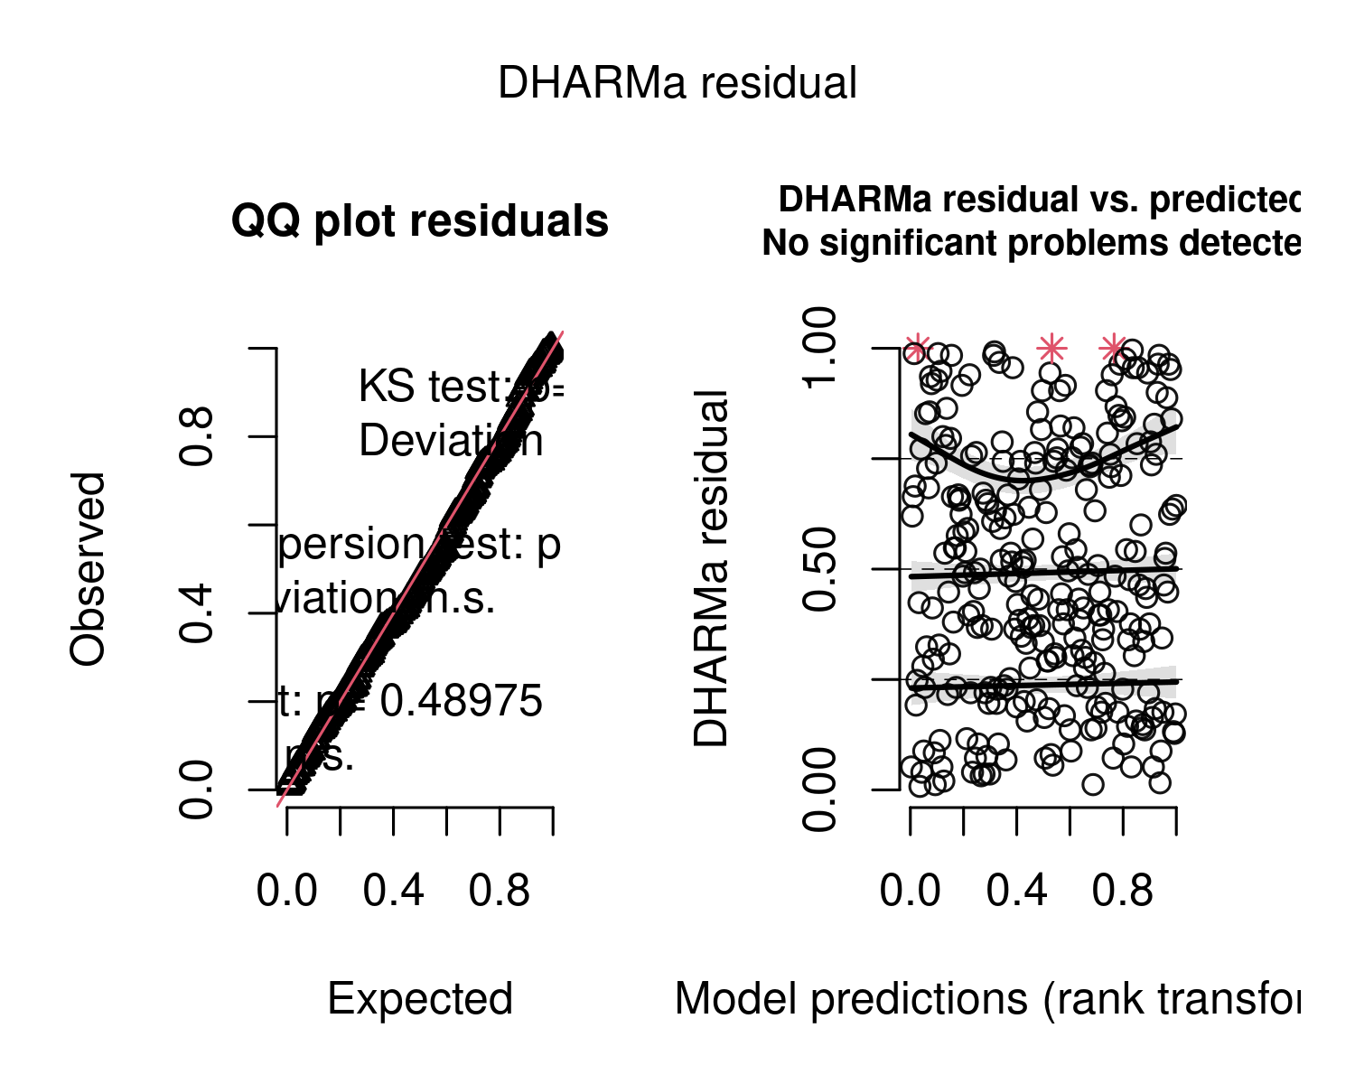
(a) Density-driven Model

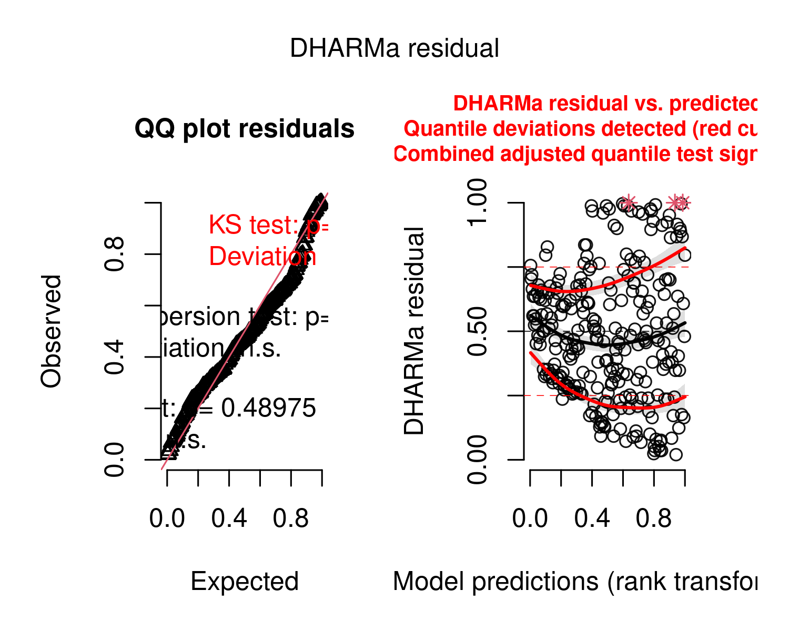
(b) Performance-based Model

Figure 8: Diagnostic plots for (A) density-driven and (B) performance-based models. Left panels show QQ-plots of residuals; right panels show residuals vs. predicted values.
Table 4: Summary of model specifications and convergence diagnostics.
Hypothesis | Family (Link) | Deviance Explained | Scale/Dispersion | DHARMa (p) | Convergence
Density-driven | gaussian(identity) | 0.7% | 1.424 | 0.864 | Converged
Performance-based | Gamma(log) | 41.7% | 0.102 | 0.208 | Converged
As detailed in Table 4, the validation phase confirms that the models are structurally sound :
- The perfomance-based model (deviance explained: 34%) effectively captures the variance in abundance using the Gamma distribution. The DHARMa p-value ($p=0.208$) confirms that the log-link successfully handled the mean-variance scaling without over dispersion.
- In the density-driven model, the very low deviance explained (2.1%) and EDF values near 0 indicate a nearly flat or strictly linear relationship. This suggests that population density is a poor predictor of selection strength, effectively ruling out a strong density-dependent “mechanical” driver.
- The gam.check results confirm we did not “choke” the models. In the performance-based model, $EDF<k′$, proving the smoothers had sufficient flexibility. In the density-driven model, the low $k$-index is an artifact of the lack of signal (linearity) rather than a lack of basis functions.
Conclusion: We accept both models for final interpretation. The performance-based approach provides a strong explanatory framework for success, while the density-driven approach serves as a robust “null-effect” test for density-dependence.

Models results
“To isolate the biological signal from environmental noise, we partitioned the deviance explained into marginal $D^{2}$ (fixed biological predictors) and random $D^{2}$ (stochastic variation from scanner and period). We prioritized $D^{2}$ over the traditional $R^{2}$ as it provides a more accurate measure of fit for the likelihood-based framework of GAMs.
We compared our full models against “null” (random effects only) models to isolate three specific components of variation:
- Total deviance ($D_{Total}^{2}$): The proportion of null deviance explained by the full model specification, including fixed factors, smooth terms, and random effects.
- Random effect deviance ($D_{Random}^{2}$): Extracted from a reduced model containing only the random intercepts (scanner and period) and parametric fixed factors (Predicted.class.levelup and root_type). It must represent the background variation inherent to the experimental design.
- Marginal deviance ($D_{Marginal}^{2}$): Calculated as $D_{Total}^{2}−D_{Random}^{2}$. This value represents the specific explanatory power gained by including the smoothed biological predictors.
Table 5: Final synthesis of model performance and deviance partitioning
 |  | Deviance Partitioning (D²) |  |  | Fit Statistics
Hypothesis | Family | Total D² | Marginal D² | Random D² | Adj. R² | AIC
Density-driven | gaussian | 0.7% | 0.5% | 0.2% | -0.006 | 894.070
Performance-based | Gamma | 41.7% | 9.5% | 32.1% | 0.276 | 364.816
Conclusion: We accept both models for final interpretation. The performance-based approach provides a strong explanatory framework for success, while the density-driven approach serves as a robust “null-effect” test for density.
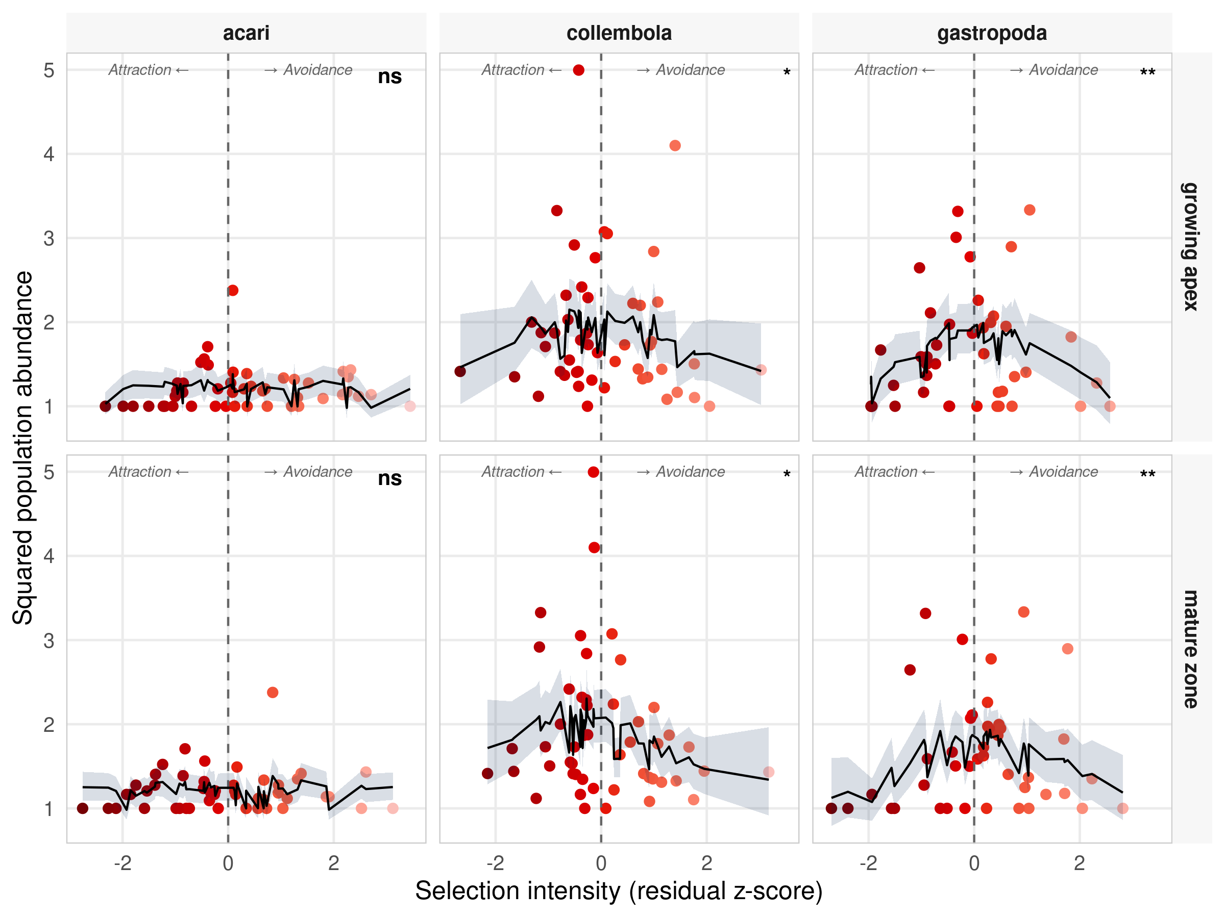
Figure 9: Demographic response to root selection intensity
The back-transformed partial effects of the performance-based model (Figure 9) visualize how specific taxa benefit from rhizosphere exploitation.

